Test Case: tc001_SPX_Dev5_Crear_Requisicion_Spot_Tipo_Cobro_CC
Step 1 - Enter username and password and click to button Enter : Credentials Entered
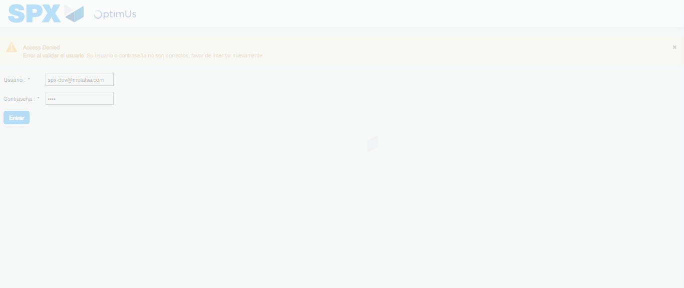Image file-name: QC_Testing-tc001_SPX_Dev5_Crear_Requisicion_Spot_Tipo_Cobro_CC-1783984186424

Step 2 - Select to UEN and Access to Spot Buy Requisitions : UEN Correctly selected and Correct access
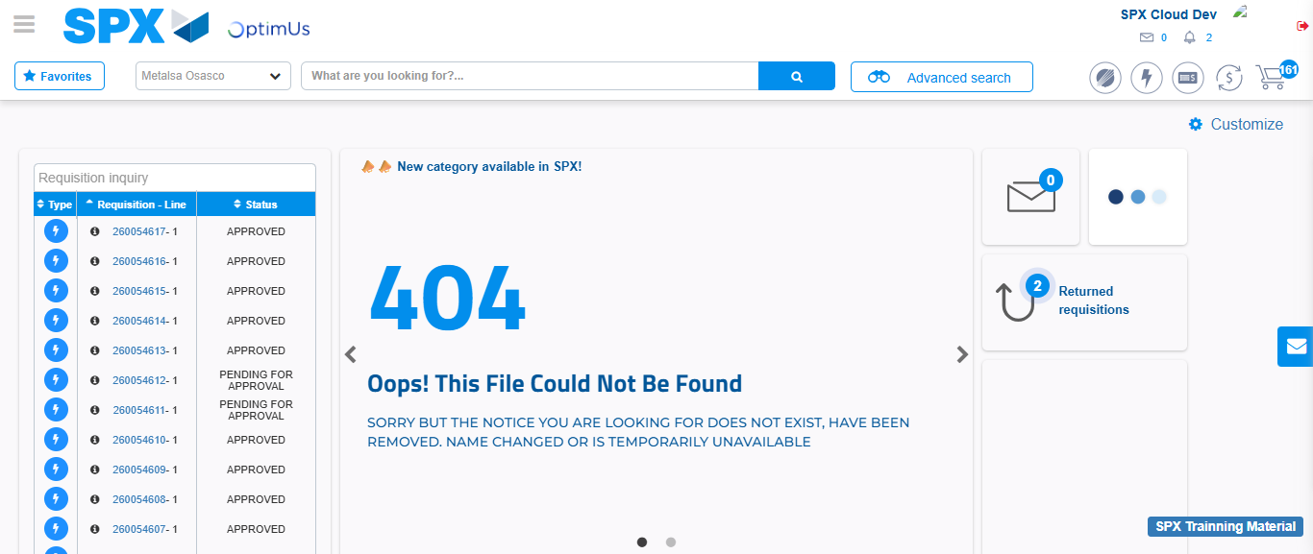Image file-name: QC_Testing-tc001_SPX_Dev5_Crear_Requisicion_Spot_Tipo_Cobro_CC-1783984212588

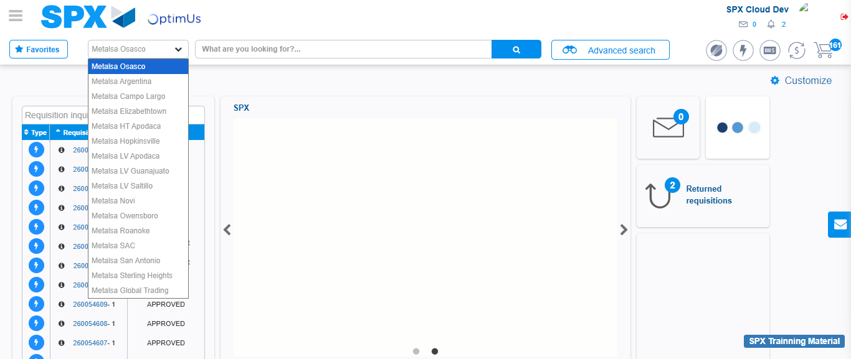Image file-name: QC_Testing-tc001_SPX_Dev5_Crear_Requisicion_Spot_Tipo_Cobro_CC-1783984215157

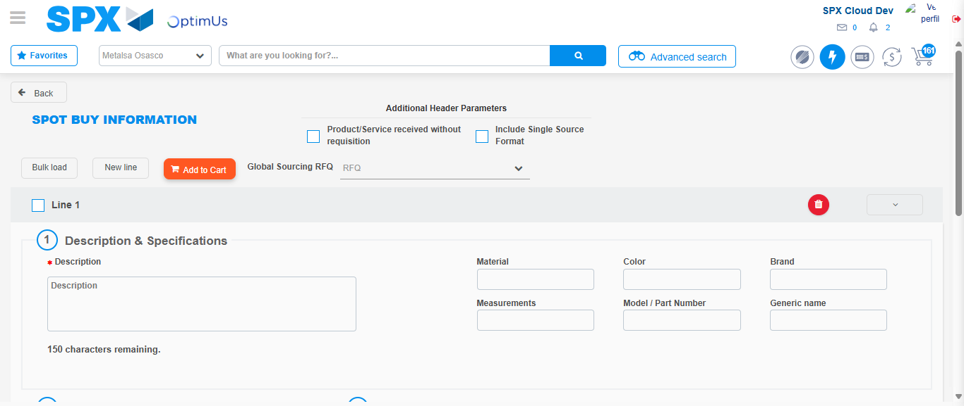Image file-name: QC_Testing-tc001_SPX_Dev5_Crear_Requisicion_Spot_Tipo_Cobro_CC-1783984233714

Step 3 - Data Capture Spot Buy Requisition : Data captured correctly
Image file-name: QC_Testing-tc001_SPX_Dev5_Crear_Requisicion_Spot_Tipo_Cobro_CC-1783984233941

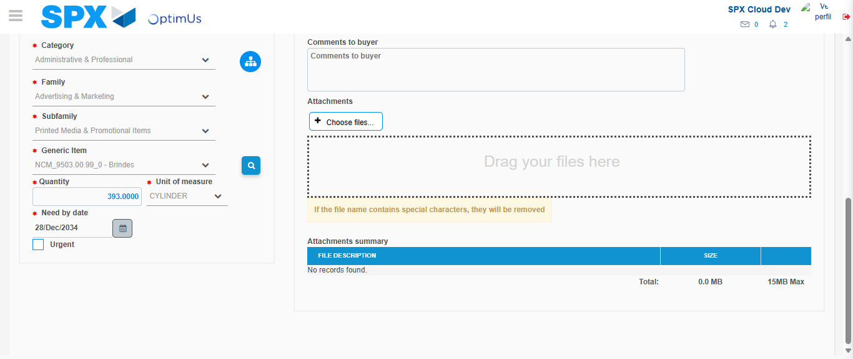Image file-name: QC_Testing-tc001_SPX_Dev5_Crear_Requisicion_Spot_Tipo_Cobro_CC-1783984245779

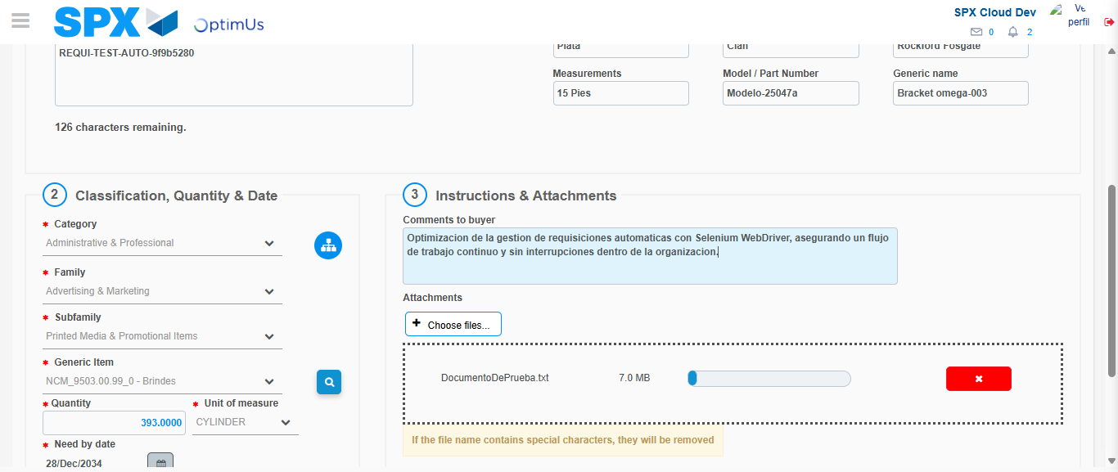Image file-name: QC_Testing-tc001_SPX_Dev5_Crear_Requisicion_Spot_Tipo_Cobro_CC-1783984246511

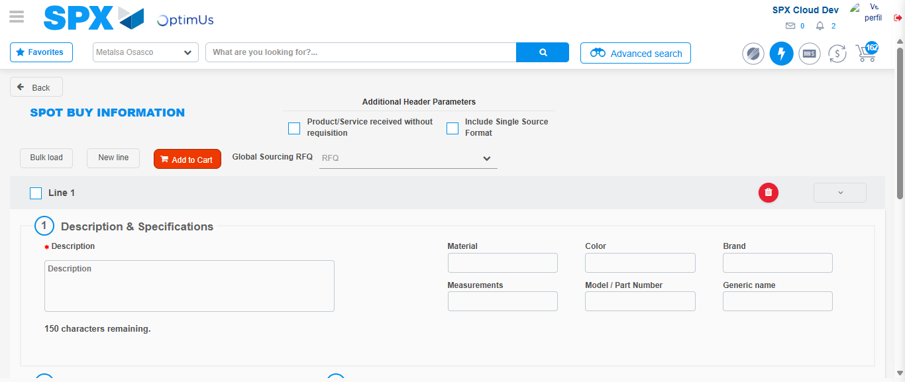Image file-name: QC_Testing-tc001_SPX_Dev5_Crear_Requisicion_Spot_Tipo_Cobro_CC-1783984256855

Step 7 - Return to Main Page SPX : Return to Main Page SPX
Image file-name: QC_Testing-tc001_SPX_Dev5_Crear_Requisicion_Spot_Tipo_Cobro_CC-1783984212588

Image file-name: QC_Testing-tc001_SPX_Dev5_Crear_Requisicion_Spot_Tipo_Cobro_CC-1783984215157

Image file-name: QC_Testing-tc001_SPX_Dev5_Crear_Requisicion_Spot_Tipo_Cobro_CC-1783984233714

Image file-name: QC_Testing-tc001_SPX_Dev5_Crear_Requisicion_Spot_Tipo_Cobro_CC-1783984259070

Image file-name: QC_Testing-tc001_SPX_Dev5_Crear_Requisicion_Spot_Tipo_Cobro_CC-1783984259231

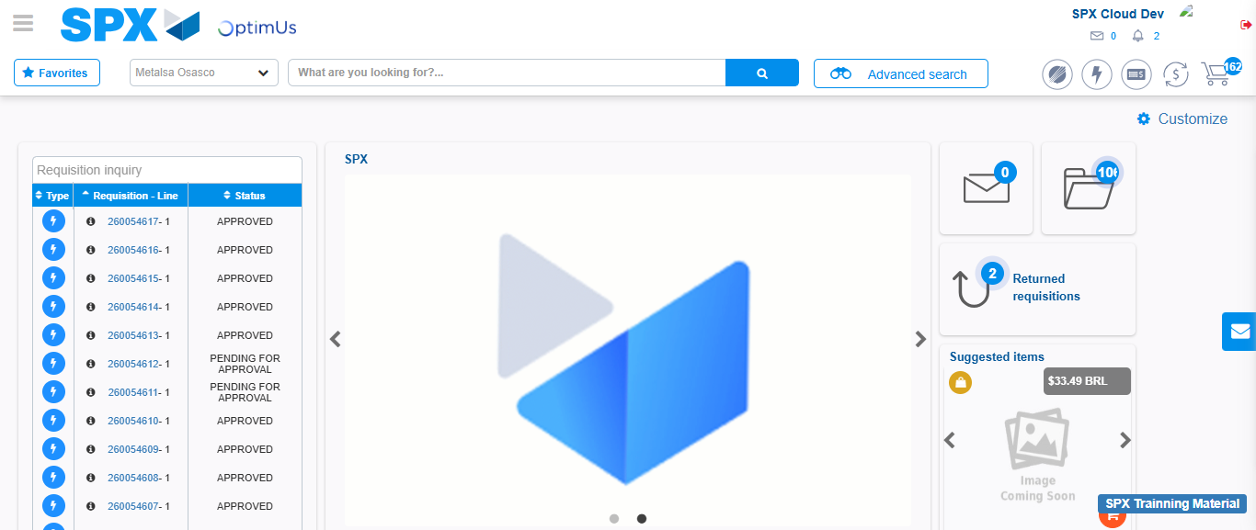Image file-name: QC_Testing-tc001_SPX_Dev5_Crear_Requisicion_Spot_Tipo_Cobro_CC-1783984280247

Step 8 - Log Out : Log Out SPX
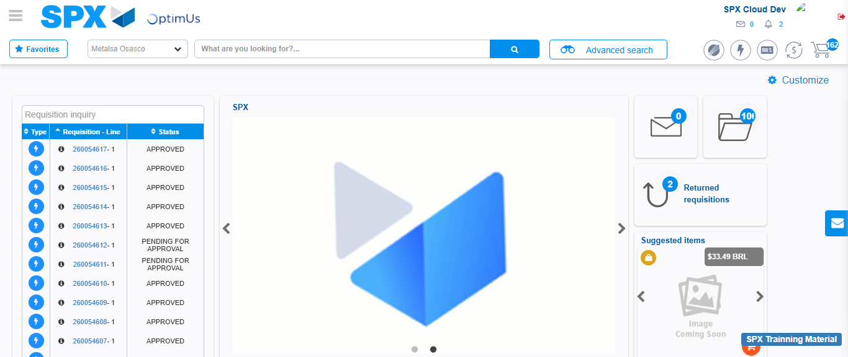Image file-name: QC_Testing-tc001_SPX_Dev5_Crear_Requisicion_Spot_Tipo_Cobro_CC-1783984280579

